GRASSLAND SOIL HEALTH RESOURCE SHEET www.herefordshiremeadows.org.uk
Summary of discussion at Upper Pengethley Farm, with Julian Partridge and Kate Adams - 16 October 2018
We looked at soils growing permanent moderately flower rich grassland in the parkland and compared this with arable reversion to permanent pasture, arable soil and a hay meadow created from arable more than a decade ago. The most important tool for understanding soil is undoubtedly the SPADE.
Assessing soil structure – physical properties
- AHDB GREAT SOILS Healthy grassland soils pocket book and 4 simple steps to assess soil structure
- Beef and Lamb Better Returns booklet Improving soils for better returns
Assessing soil biology - worm ID sheets – they are brilliant indicators of soil health
30 minute worm survey - 3 groups of earthworms and Opal worm ID guide with worm names
Understanding soil chemistry P,K,Mg,pH soil analysis plus soil organic matter levels can be arranged through Hfds Meadows. Ask Caroline Hanks or your adviser for lab fee and to borrow soil corer
Two charts on the relationship between soil pH and nutrient availability and interaction of nutrients explain why applying nutrients outside optimal pH is a waste of money as well as reducing wild plant diversity. ADVICE page of website lists local advisers who can help you choose the best locations for meadow restoration and creation on your farm.
Plants and grazing management have critical roles to keep soils healthy
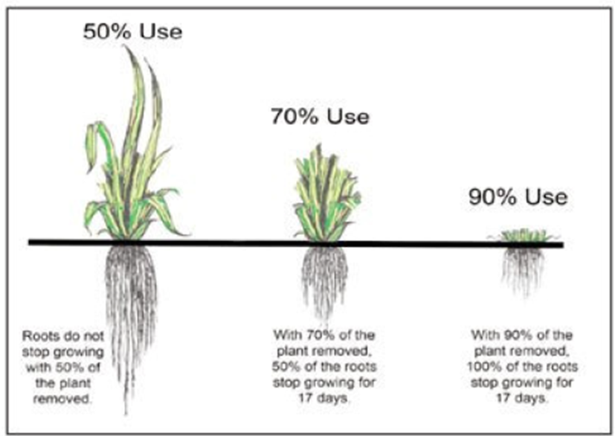
We saw that reversion to grassland doesn’t necessarily raise organic matter content or improve soil structure automatically unless grazing is also planned carefully.
Diagram to left shows potential of grazing management with rest periods to build soil organic matter, structure and health by having large leaf area and letting photosynthesis do its thing – note the effects of >50% use on root growth.
Our final assessment in Julian’s hay meadow revealed the deepest roots and best structured soils seen all afternoon.
Key messages
- All grassland swards benefit from healthy soil; from wildflower meadows to ryegrass /clover leys
- Know your swards and check soil health before starting any meadow project. Increase in nutrient status and change of pH can adversely affect plant diversity. Ask for ADVICE before you start.
- Planned rotational grazing is a useful tool in flower rich grassland as well as herbal leys to increase soil health and grass productivity.
- Where soil health is poor consider using herbal leys as a transition before investing time and money in purchased or locally harvested native wildflower seed
- Aim for productive, species rich grassland and herbal leys to improve drought resilience, withstand poaching in wet weather and to support healthy livestock businesses

For photos and more about Herefordshire Meadows discussion at Upper Pengethley Farm go to NEWS
Digital copy with active links is available on website – search for SOIL or RESOURCES
For further information please contact Caroline Hanks (caroline.hanks@farming4wildlife.co.uk) 07779 080940 / 01981 251016

