

**Small scale Grazing Strategies**

**At Brookmead, Old Church Road, Colwall, WR13 6HA.**

**Courtesy of Lindsay Williams and Colwall Orchard Group**

**A workshop and discussion group meeting led by Herefordshire Meadows members who are tenant farmers, meadow owners and conservation graziers including James Hawkins, Sue Holland and Caroline Hanks**

**Wednesday 17th April 2019**

**4 – 6.30 pm**

**Light refreshments. Please bring your own mug**

Meet at Colwall Orchard Group Apple Shed WR13 6HA. We will walk around Brookmead and Orchard Group fields to discuss practicalities of managing grazing on a small scale. Returning to the shed you will consider a grazing plan for your own fields.

**PLEASE BRING A MAP OF YOUR FIELDS and some coloured pens**

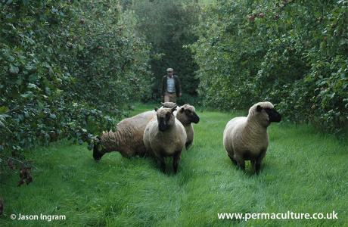****

This event is for anyone who wants to explore different ways to manage flower rich grassland with their own livestock or with a grazier / tenant. Topics to be covered include:

* Grazing strategies to improve grass production and sward diversity – how do they work at small scale?
* Win win solutions for grassland owners and graziers
* What infrastructure do I need?
* How does this fit with stewardship schemes

**Stout waterproof shoes or boots and outdoor clothing essential**

**Numbers limited and Booking ESSENTIAL. Cancellations to be notified as early as possible please as we will be running a waiting list for this event**

**Booking through Herefordshire Rural Hub**

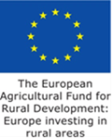Email: [**bookings@herefordshireruralhub.co.uk**](mailto:bookings@herefordshireruralhub.co.uk)or telephone **01432 353465**

Enquiries to Caroline Hanks [caroline.hanks@farming4wildlife.co.uk](mailto:caroline.hanks@farming4wildlife.co.uk) 07779 080940 01981 / 251016

[**www.herefordshiremeadows.org.uk**](http://www.herefordshiremeadows.org.uk)

Herefordshire Meadows is supported by Natural England’s Countryside Stewardship Facilitation Fund